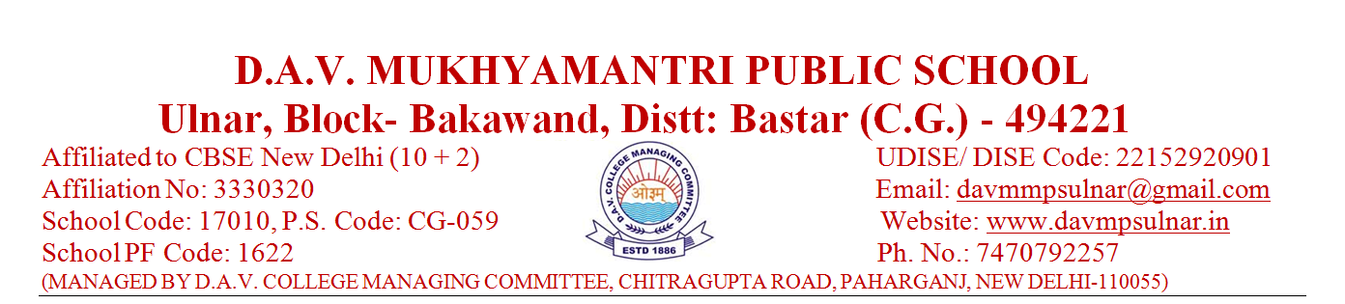
DAV Mukhyamantri Public School, Ulnar
CBSE Result of Sr. Secondary Examination 2022-23
S. no. | Name of School | District | Class | No of Students |  |  |  | Pass % | Division |  |  | School Topper Stream wise % | No. of 90 % and above | Overall QPI.
 |  |  |  | Appeared | Passed | Failed | Compartment |  | 1st | 2nd | 3rd
01 | DAV Mukhyamantri Public School, Ulnar | Bastar | 12th | 15 | 02 | 10 | 03 | 13 | 02 | 00 | 00 | Varsha Sinha 61.8 (Science) | 00 | 45.89%

Principal
DAV Mukhyamantri Public School, Ulnar

DAV Mukhyamantri Public School, Ulnar
CBSE Result of Secondary Examination 2022-23
S. no. | Name of School | District | Class | No of Students |  |  |  | Pass % | Division |  |  | School Topper Stream wise % | No. of 90 % and above | Overall QPI.
 |  |  |  | Appeared | Passed | Failed | Compartment |  | 1st | 2nd | 3rd
01 | DAV Mukhyamantri Public School, Ulnar | Bastar | 10th | 17 | 05 | 02 | 10 | 29.41 | 01 | 02 | 02 | Kirti Sori 60 | 00 | 40.11%

Principal
DAV Mukhyamantri Public School, Ulnar

